Lab 9: Schema Evolution & Time Travel

Table of Contents
Table of Contents 2
Introduction 3
Learning Objectives 3
Prerequisites 3
Part 1 — Perform Schema Evolution 4
Part 2 — Inspect Table Snapshots 6
Part 3 — Querying with Time Travel 8
Knowledge Check 10
Conclusion 10

Introduction
In traditional Data Lakes (like Apache Hive), changing a table's schema or rolling back to a previous state is a massive headache, often requiring rewriting entire partitions of data.
Because Apache Iceberg tracks all table changes using Metadata Snapshots, it provides two incredibly powerful features:
- Schema Evolution: You can add, drop, or rename columns instantly without rewriting any underlying data files.
- Time Travel: You can query the exact state of the table as it existed at any point in the past.
In this lab, we will evolve the schema of the table we built in Lab 8, insert new records, and use Time Travel to look back at the old data.

Learning Objectives
Upon completing this lab, you will be able to:
- Evolve an Iceberg table schema safely.
- View the snapshot history of an Iceberg table.
- Execute Time Travel queries to retrieve historical data.

Prerequisites
- Completion of Lab 8.
- You must still be in the ~/iceberg-labs directory with the warehouse folder intact.

Part 1 — Perform Schema Evolution
We will write a script to alter our table, adding a subscription_tier column, and then insert new records.
Create a new file:
nano iceberg_evolution.py

Paste the following code:
from pyspark.sql import SparkSession
import os
spark = SparkSession.builder \
.appName("IcebergEvolution") \
.config("spark.jars.packages", "org.apache.iceberg:iceberg-spark-runtime-3.5_2.12:1.5.0") \
.config("spark.sql.extensions", "org.apache.iceberg.spark.extensions.IcebergSparkSessionExtensions") \
.config("spark.sql.catalog.local", "org.apache.iceberg.spark.SparkCatalog") \
.config("spark.sql.catalog.local.type", "hadoop") \
.config("spark.sql.catalog.local.warehouse", f"{os.getcwd()}/warehouse") \
.getOrCreate()
print("1. Evolving Schema: Adding 'subscription_tier' column...")
spark.sql("ALTER TABLE local.db.users ADD COLUMN subscription_tier string")
print("2. Inserting new records with the new schema...")
spark.sql("""
INSERT INTO local.db.users VALUES
(3, 'Charlie', DATE '2023-01-03', 'Premium'),
(4, 'Diana', DATE '2023-01-04', 'Basic')
""")
print("3. Current Table State (Notice the new column):")
spark.sql("SELECT * FROM local.db.users").show()
spark.stop()

(Save and exit using Ctrl+X, Y, Enter).

Run the script:
python3 iceberg_evolution.py

Expected Output:
3. Current Table State (Notice the new column):
+---+-------+-----------+-----------------+
| id| name|signup_date|subscription_tier|
+---+-------+-----------+-----------------+
| 1| Alice| 2023-01-01| NULL|
| 2| Bob| 2023-01-02| NULL|
| 3|Charlie| 2023-01-03| Premium|
| 4| Diana| 2023-01-04| Basic|
+---+-------+-----------+-----------------+
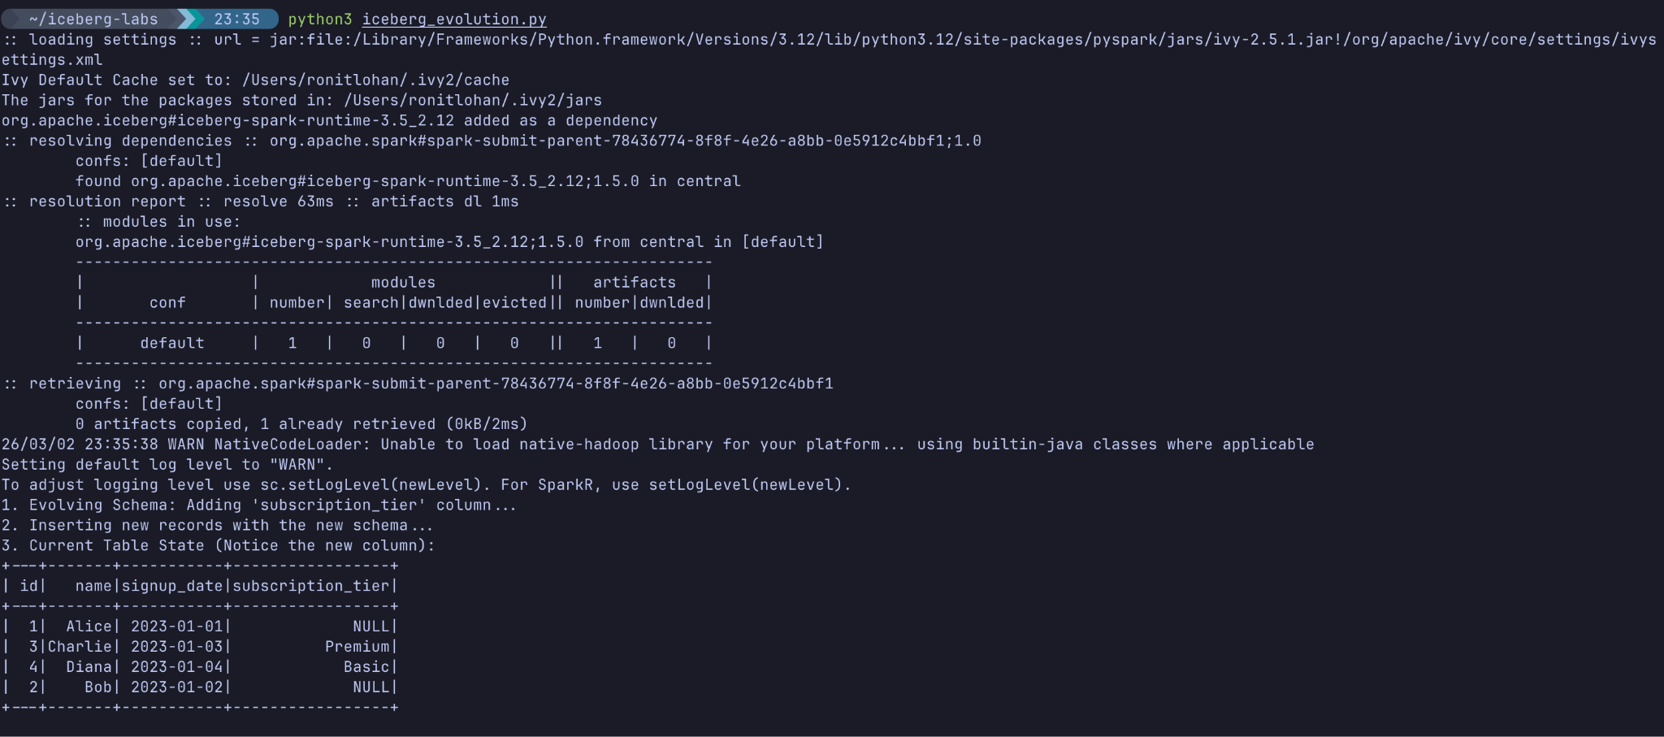

Notice: Iceberg instantly added the column. The old data (Alice and Bob) seamlessly show up with NULL for the new column, without requiring us to rewrite their original Parquet files!

Part 2 — Inspect Table Snapshots
Every time we write to an Iceberg table, it generates a new Snapshot in the metadata. Iceberg tables have built-in hidden metadata tables that we can query to see this history.
Create and run a quick script to view the snapshot history:
nano iceberg_history.py

Paste this code:
from pyspark.sql import SparkSession
import os
spark = SparkSession.builder \
.appName("IcebergHistory") \
.config("spark.jars.packages", "org.apache.iceberg:iceberg-spark-runtime-3.5_2.12:1.5.0") \
.config("spark.sql.extensions", "org.apache.iceberg.spark.extensions.IcebergSparkSessionExtensions") \
.config("spark.sql.catalog.local", "org.apache.iceberg.spark.SparkCatalog") \
.config("spark.sql.catalog.local.type", "hadoop") \
.config("spark.sql.catalog.local.warehouse", f"{os.getcwd()}/warehouse") \
.getOrCreate()
print("Table Snapshot History:")
# Query the hidden '.history' metadata table
history_df = spark.sql("SELECT made_current_at, snapshot_id FROM local.db.users.history")
history_df.show(truncate=False)
# Save the first snapshot ID to a local file so we can use it in Part 3
first_snapshot = history_df.collect()[0]['snapshot_id']
with open('first_snapshot_id.txt', 'w') as f:
f.write(str(first_snapshot))
spark.stop()

(Save and exit).
Run it:
python3 iceberg_history.py
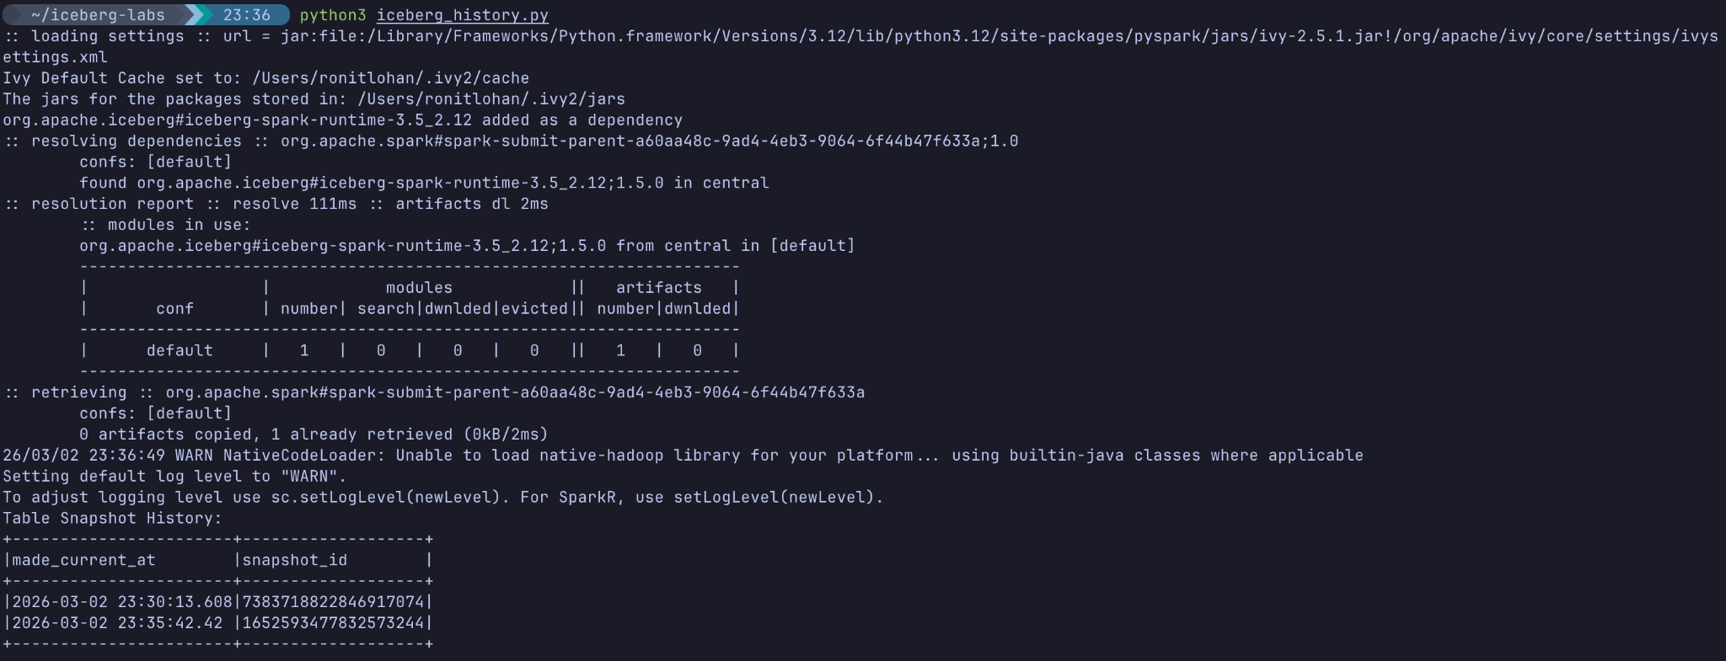
Expected Output:
You will see a table with timestamps and long snapshot_id numbers. You should see at least two snapshots: one from when we created the table in Lab 8, and one from our inserts today.

Part 3 — Querying with Time Travel
What if we made a mistake and needed to query the table exactly as it looked before we added the subscription_tier column and the new users?
Iceberg supports a VERSION AS OF SQL clause.
Let's run a script that reads the first snapshot ID we saved, and queries it:
nano iceberg_time_travel.py

Paste the following:
from pyspark.sql import SparkSession
import os
spark = SparkSession.builder \
.appName("IcebergTimeTravel") \
.config("spark.jars.packages", "org.apache.iceberg:iceberg-spark-runtime-3.5_2.12:1.5.0") \
.config("spark.sql.extensions", "org.apache.iceberg.spark.extensions.IcebergSparkSessionExtensions") \
.config("spark.sql.catalog.local", "org.apache.iceberg.spark.SparkCatalog") \
.config("spark.sql.catalog.local.type", "hadoop") \
.config("spark.sql.catalog.local.warehouse", f"{os.getcwd()}/warehouse") \
.getOrCreate()
# Read the snapshot ID from our previous step
with open('first_snapshot_id.txt', 'r') as f:
snapshot_id = f.read().strip()
print(f"Time Traveling back to Snapshot ID: {snapshot_id}")
# Run the time travel query
query = f"SELECT * FROM local.db.users VERSION AS OF {snapshot_id}"
spark.sql(query).show()
spark.stop()

(Save and exit).
Run it:
python3 iceberg_time_travel.py
Expected Output:
+---+-----+-----------+
| id| name|signup_date|
+---+-----+-----------+
| 1|Alice| 2023-01-01|
| 2| Bob| 2023-01-02|
+---+-----+-----------+
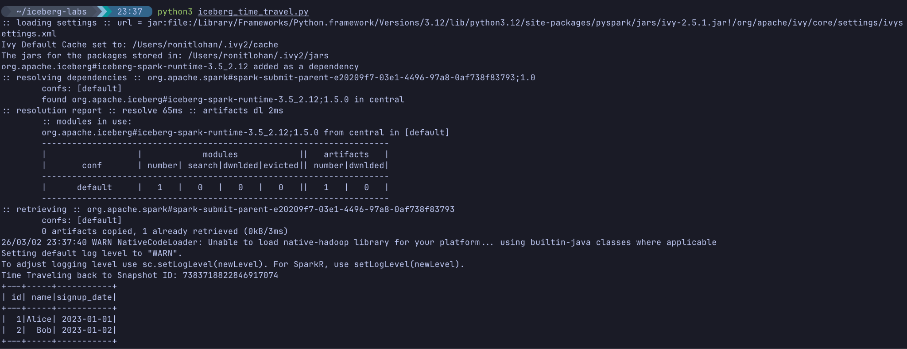
Magic! We queried the same local.db.users table, but the engine returned the exact rows and exact schema (no subscription_tier column) that existed during that specific snapshot.

Knowledge Check
- How does Iceberg manage Schema Evolution without rewriting data?
- Answer: Iceberg tracks column schemas by unique IDs in the metadata, not by position in the Parquet file. Old data files simply return NULL for newly added columns.
- What is an Iceberg Snapshot?
- Answer: A snapshot represents the complete state of the table at a specific point in time, tracking exactly which data files are valid.
- What SQL syntax is used in Spark to query a previous snapshot?
- Answer: VERSION AS OF <snapshot_id> or TIMESTAMP AS OF <timestamp>.

Conclusion
In this lab, you experienced why Iceberg is the gold standard for Lakehouse architectures. You evolved a table's schema in milliseconds and successfully executed a time travel query to retrieve historical state.
These capabilities are critical when building real-time pipelines. If bad data is streamed into your Lakehouse, Iceberg's snapshot mechanism allows you to simply roll back the table instantly, making your data infrastructure highly resilient!

